Estimating shifts in squid distribution

**Methods**

*Data*

We obtained squid catch data from fishery independent surveys conducted by the Northwest Fisheries Science Center (NWFSC) from 1998 to 2019, and from 2010 to 2016 for the Southwest Fisheries Science Center (SWFSC) (Figure 1). All trawls were conducted during the day. The locations of the trawls for the NWFSC and SWFSC were a combination of predetermined transects (citation, Emmett or Peterson) and *ad hoc* adjustments in years with low catches or limited research funds.

Trawl effort was defined by 30 minutes tows; however, for our purposes we used area swept as calculated by the GPS coordinates between start and end points and the effective width of the trawl opening – estimated to be approximately 28 meters (Brodeur et al., 2005; Emmett et al., 2006; Harding et al., 2011). The total number of squid in each trawl were counted when reasonable, or the total catch was extrapolated from a sample weight for a known volume of squid when catches exceeded the science crew’s capacity to finish processing fish between trawls. Up to 50 individual squid lengths were recorded for each trawl: we assume the length frequency of the entire catch was the same as the length frequency of the sample. Additionally, biophysical data such as the temperature ($°C$), chlorophyll concentration (mg m-3 ???), and salinity (ppm) were collected at three meters before each trawl.

Potential biases exist based on the gear, vessel, and crew that were used. For the NWFSC, the F/V Ocean Star conducted surveys from 1998 to 2000, and the F/V Frosti conducted surveys from 2001 to 2019. During that time, any changes in the science and vessel crew leads occurred after overlap with previous crews. The F/V XX was used to conduct the SWFSC surveys from 2010 to 2016. Similar to the NWFSC surveys, there was significant overlap between years for both the science and vessel crews. The net was a 264 Nordic rope trawl (see NMFS (2008) and Krutzikowsky and Emmett (2005) for a complete description). To prevent the capture of non-target species, a marine mammal excluder device was added to the SWFSC surveys from 2012 to 2016, and NWFSC surveys from 2014 to 2019. During the initial year of deployment the MMED was placed in an upward position, but was changed to a downward position in subsequent years. Paired trawls, with and without the MMED were conducted to evaluate the effects of the MMED. Squid catches declined by 12% and 52% when the MMED was in upward and downward position, respectively (Wainwright et al., 2019). Based on our best available knowledge when addressing these potential biases, we chose to assume that there is no crew or vessel bias between years. One option would be to compare the spatiotemporal synchrony for the NWFSC and SWFSC surveys; however, with no spatial overlap, and only a small number of year of sampling for the SWFSC, models comparing the temporal synchrony of the two surveys failed to converge during preliminary analyses. Therefore, we treated the catches from the SWFSC and NWFSC as a single survey. Future work may consider methods for disaggregating these two surveys to examine biases, but that is currently beyond the scope of this analysis. Finally, we adjusted the total squid catches *a prior* for years with MMED using the catch ratios for the upward and downward position (12% and 52%, respectively) found in Wainwright et al. (2019).

*Spatiotemporal model*

To account for the unbalanced design of the two surveys, we used a geostatistical model with random processes describing the effects of space and time on the estimated catches of market squid. The delta-generalized linear model (delta-glmm) consists of two parts, the probability of encountering squid during a survey, and the probability of positive catches if squid were encountered

Equation .

For the ith sample, $c_{i}$ is observed number of squid captured, $p_{i}$ is the probability of positive catches, $r_{i}$ is the expected number of squid captured given positive catches, $a_{i}$ is the effort offset (i.e., distance fished times the average opening of the net, 0.085 km), $σ^{2}$ is the observed error not explained by biological or environmental covariates, or random variation in the spatiotemporal distribution of the catches, and g is a probability distribution describing the positive catches (e.g., gamma, log-normal, etc.). The joint probability for the observations includes a probability for the encounters and positive catches. Because we did not have true counts of the squid (i.e., the number of squid were often extrapolations based on weights or volumes) we chose to compare fits by comparing the gamma and log-normal distributions (e.g., $g\sim gamma\left(σ,\frac{σ}{a_{i}×r_{i}}\right)$ or $g∼lognormal\left(a_{i}×r_{i},σ^{2}\right)$, where $1/\sqrt{σ}$ and $\sqrt{\exp\left(σ\right)-1}$, respectively, are equal to the coefficient of variation for the observations) rather than the Poisson or negative-binomial distribution. For the encounter probability, we assumed a Bernoulli distribution ($p_{i}∼Bernoulli(0)$).

Briefly, the geospatial model in VAST includes linear estimators for the encounter probability (Equation 2) and positive catches (Equation 3) based on the i) intercepts, ii) covariates, and iii) spatial and spatiotemporal processes,

Equation .

Equation .

Based on an initial analysis of the size distribution data (Supplemental figure xx), we found little evidence of distinct modes in the data that would support a dynamic factor analysis. Market squid grow quickly, spawn continuously, and only live one year (citation) making unlikely that an annual survey would detect cohort differences. The intercept parameters $\left(β_{p} and β_{r}\right)$ represent estimates of the annual changes in the encounter probability and positive catches, respectively, for category $c_{i}$ in year $t_{i}$ for the ith observation. The spatial $\left(ω_{p}\left(s_{i}\right) and ω_{r}\left(s_{i}\right)\right)$ and spatiotemporal $\left(ε_{p}\left(s_{i},t_{i}\right) and ε_{r}\left(s_{i},t_{i}\right)\right)$ random effects describe the residual variance not explained by the fixed intercepts or covariates for location $s_{i}$ of the ith observation.

Our current analysis includes only a single species (i.e., squid) and one length bin. The parameters $λ_{p}\left(k\right) and λ_{r}(k)$ describe the change in the catchability of squid based on the kth covariate related to the ith observation $\left(Q\left(i,k\right)\right)$. Because the covariates are related to the observation, there is no subscript for the encounter or positive catch models. Catchability covariates are different from density covariates: density covariates are observed at every location in every year and are useful for extrapolation and forecasting which are not related to our analysis at this time. The catchability covariates are anything that could affect catch rates but not density. In our case, we have data on the temperature, chlorophyll a concentrations, and salinity at a depth of 3m; all these covariates could affect the vertical distribution and catch rates of squid as they search for suitable habitat and prey concentrations. For the observation models, we assume the encounter are binomial distributed, and the positive catches are log-normally distributed.

*Model estimation, validation and selection*

To estimate the parameters of the model and partition the variance associated with different random effects, we used the variance-autoregressive spatiotemporal (VAST) package in the R (Thorson 2016 – get citation). Thorson (2019) provides a detailed description of the statistical properties of VAST models. We followed Thorson’s fifteen step decision tree when implementing the spatiotemporal model in the VAST package (Table 2). VAST uses the Template Model Builder libraries (TMB package; Kristensen et al. 2015) for R, to maximize the marginal likelihood of the fixed effects, while integrating out the random effects (geopspatial and temporal variation) using a Laplace approximation. Alternative models, to the base case model listed in Table 2 were based environmental covariates, and the type of random error (temporal, spatial, and or spatiotemporal) that was included.

Given the large number of random effects needed to estimate the geospatial effects in the model, we first checked that the fixed-effects of each model are identifiable based on the matrix of second derivatives for the marginal likelihood. Second, we used AIC (Akaike 1974) to select among different model configurations that may or may not include catchability coefficients and spatiotemporal processes. For the best model chosen based on AIC, we k-fold cross-validation to determine how well the model will perform on an unknown dataset.

**Results**

We were able to fit geostatistical models to fisheries independent squid catches between 1998 and 2019, and the results suggest a large amount of spatiotemporal variability between years for encounter probability and density of squid for the top model selected by AIC (Table xx). Results from the geostatistical suggest that the range of the center of gravity (COG) of the survey catches has moved between 150 km north and south and 30 km east and west (Figure 4); but there has been little trend in those shifts over time. Furthermore, the large shift in the distribution during 2015 was due to increased catches across the entire Oregon and Washington coast, with a particularly large hotspot of catches around the Oregon/California border (Figure 3 and Figure 4).

When we compared the coastwide catches to disaggregated catches for California, Oregon, Washington, and the coastwide (Figure 5), we found strong synchrony between each area, providing further evidence that squid populations are increasing their traditional and marginal habitat. With the largest increases coming xx and the lowest coming in xx. We did find an increase in the range for both size classes of squid: between 1998 and 2019, small and large squid expanded their ranges by xx and xx percent, respectively, in the surveyed water (Figure 6).

We explored several model configurations for the squid and used AIC to determine which models produced the best fit to the data. Among the models we tested, those with catchability covariates, spatial, and spatiotemporal process performed the best (Table

Tables

Table . Description of model data, parameters, variables, and subscripts.

|  |  |
| --- | --- |
| Subscripts | Description |
| $$i$$ | ith observation |
| $$r$$ | References observations with positive catches |
| $$p$$ | References observations with zero catch |
| Indexes |  |
| $$t_{i}$$ | Year |
| $$c_{i}$$ | Length category |
| $$s_{i}$$ | Station were catches occurred |
| $$n_{t}$$ | Number of years |
| $$n_{i}$$ | Number of observations |
| $$n_{c}$$ | Number of categories |
|  |  |
| Fixed effects |  |
| $$β_{p}\left(c_{i},t_{i}\right) and β_{r}\left(c_{i},t_{i}\right)$$ | Intercepts for zero ($p$) and positive catches ($r$), for the category ($c_{i}$) and year ($t_{i}$) of the ith observation |
| Random effects |  |
|  |  |
|  |  |

Table . VAST decision tree. The object data is based on the xx.csv.

|  |  |  |
| --- | --- | --- |
| Decision | Description | VAST |
| 1) Spatial domain used when calculating derived quantities | The west coast of the US from San Francisco Bay to the northern tip of Washington State. We divide the coast into four strata, with ‘coastwide’ as an aggregate for the three states | strata.limits <- data.frame(  'STRATA' = c("Coastwide","CA","OR","WA"),  'north_border' = c(49.0, 42.0, 46.0,49.0),  'south_border' = c(32.0, 32.0, 42.0, 46.0)  )) |
| 2) Which categories (species/sizes) to include | a single size class, or two size classes $≤80$ and $>80$, or | c_i <- data$c_i |
| 3) Identify whether to analyze encounter, abundance, and/or biomass-sampling data | The extrapolated number of squid captured. | b_i <- data$b_i |
| 4) Including spatial and/or spatiotemporal variation | The full model has spatial and spatiotemporal process for the encounter probability and positive catches for each size category. See step 6, for multivariate model. | FieldConfig <- c("Omega1" = 2, "Epsilon1" = 2, "Omega2" = 2, "Epsilon2" = 2) |
| 5) Choosing the spatial smoother and resolution | We used a “mesh” grid, with 200 nodes, and assume geometric anisotropy – east/west and north/south deviates are not symmetric. | Mesh.Method <- "Mesh"  n_x <- 200  Aniso <- TRUE |
| 6) Choosing the number of spatial and spatio-temporal factors | We evaluate a full rank model where each length category has its own covariance matrix. The “2” represents separate spatiotemporal process for the two size categories. | FieldConfig <-c(Omega1 =2, Epsilon1 =2, Omega2 =2, Epsilon2 =2) |
| 7) Specifying temporal correlation on model components | We test whether there is “1” or is not “0” temporal correlations in the intercepts or spatiotemporal processes. Default is not temporal correlation. | RhoConfig= c("Beta1"=0, "Beta2"=0, "Epsilon1"=0, "Epsilon2"=0) |
| 8) Including density covariates as a semi-parametric model | We have no density dependent covariates for the model |  |
| 9) Accounting for catchability covariates and confounding variables | We include catchability covariates for temperature, chlorophyll a, and salinity at 3m | Q_ik <- raw[,c('x3m_Temp','x3m_Salinity','x3m_Chl')] |
| 10) Treating area swept as a catchability covariate or offset | Area towed, distance towed for the ith sample times the width of the net – 0.085km | a_i <- raw$effort |
| 11) Including vessel effects as overdispersion | There is only a single vessel for each survey; therefore, we do not include any vessel effects | OverdispersionConfig <- c("Eta1"=0, "Eta2"=0) |
| 12) Choosing among link functions and distributions | We assume a delta-GLMM with a log-normal distribution for the positive catches | ObsModel <- c(2,0) |
| 13) Derived quantities | Center of gravity  Annual estimate of squid density | Options = c(SD_site_density = 0  ,SD_site_logdensity = 0  ,Calculate_Range = 1  ,Calculate_evenness = 0  ,Calculate_effective_area = 1  ,Calculate_Cov_SE = 0  ,Calculate_Synchrony = 0  ,Calculate_Coherence = 0) |
| 14) Bias correction for derived quantities |  |  |
| 15) Model selection | AIC |  |

Table . Model selection criteria for the different model combinations.

|  |  |  |  |  |  |  |  |  |
| --- | --- | --- | --- | --- | --- | --- | --- | --- |
| Model | AIC | Length bins | $$Ω_{1},ϵ_{1},Ω_{2},$$ FieldConfig <- c("Omega1" = 2, "Epsilon1" = 2, "Omega2" = 2, "Epsilon2" = 2) |  |  |  |  |  |
|  |  | 1 |  |  |  |  |  |  |
|  |  | 2 |  |  |  |  |  |  |

Figures

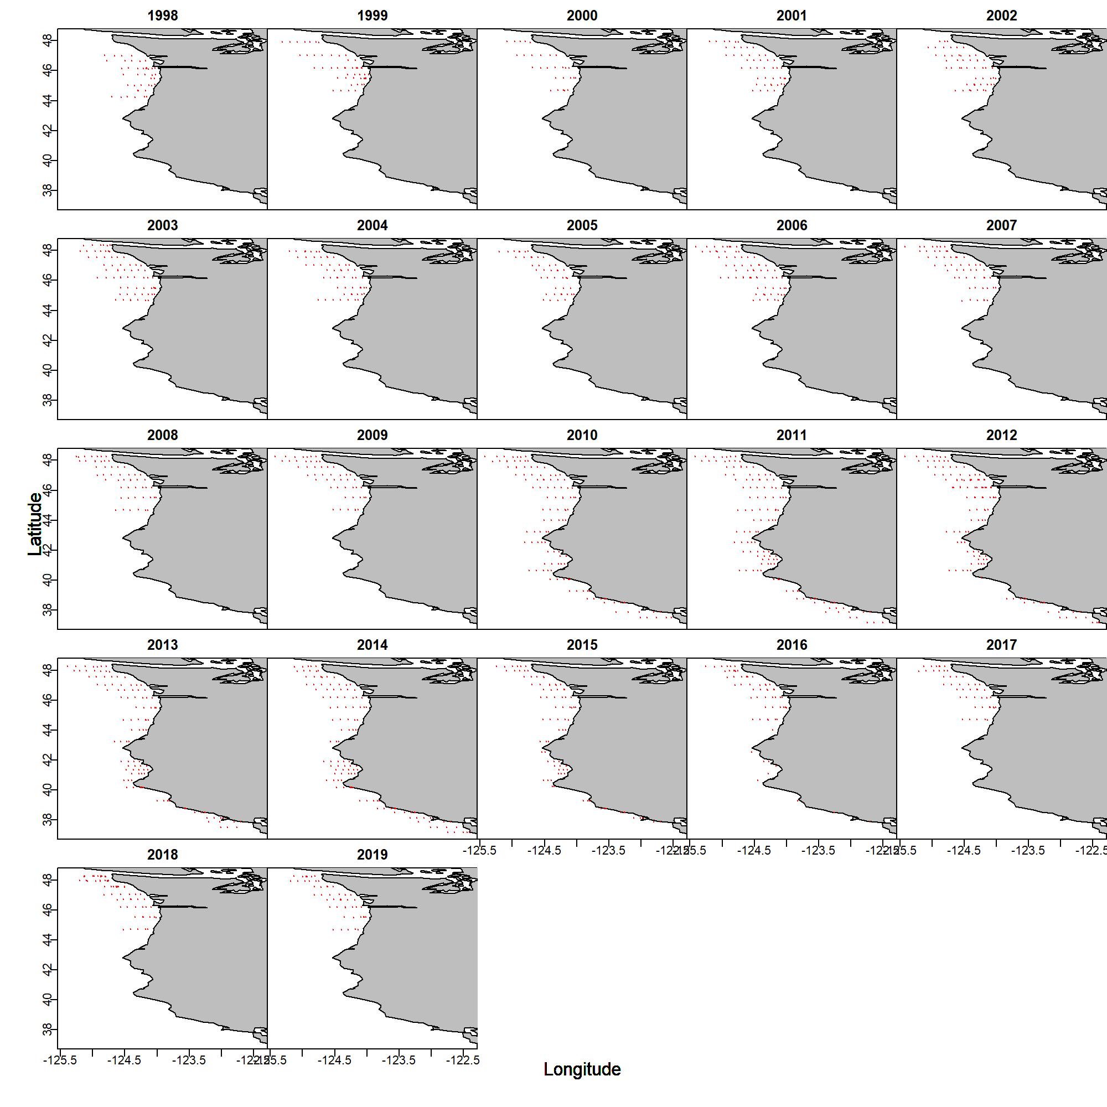

Figure . Location of samples for the 22 year data set. (We should probably color code by survey).

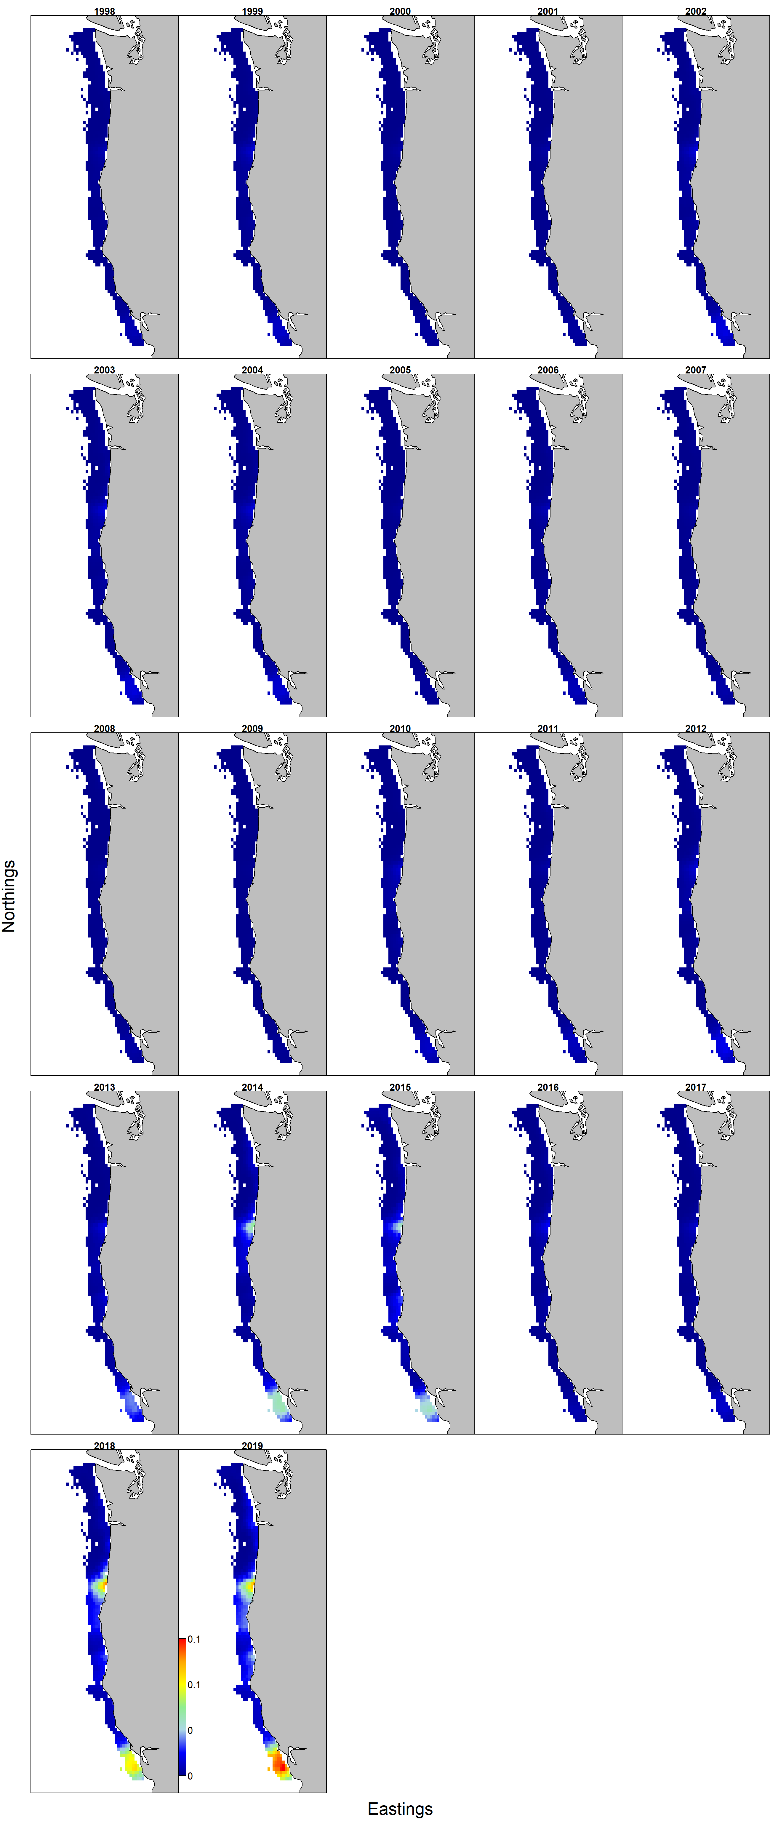

Figure . Estimated encounter probabilities for small ($≤80$) and ($>80$) large squid collected during fisheries independent surveys by the NWFSC and SWFSC between 1998 and 2019

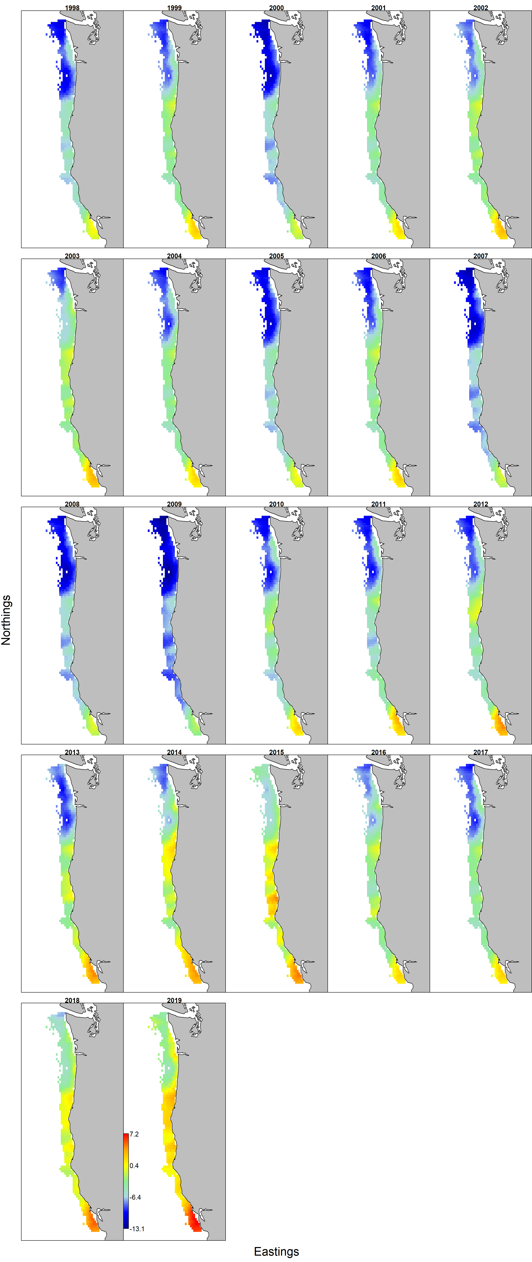

Figure . Estimated log-transformed densities for small ($≤80$) and ($>80$) large squid collected during fisheries independent surveys by the NWFSC and SWFSC between 1998 and 2019.

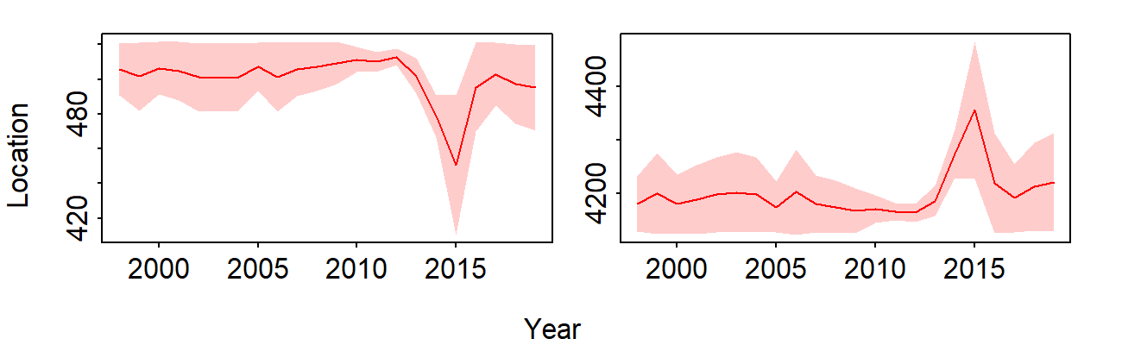

Figure . Estimated temporal easting (left panel, larger values more easterly) and northing (right panel, larger values more northerly) shifts in the center of gravity of the distribution for small and large squid collected during fisheries independent surveys conducted by the NWFSC and SWFSC between 1998 and 2019.

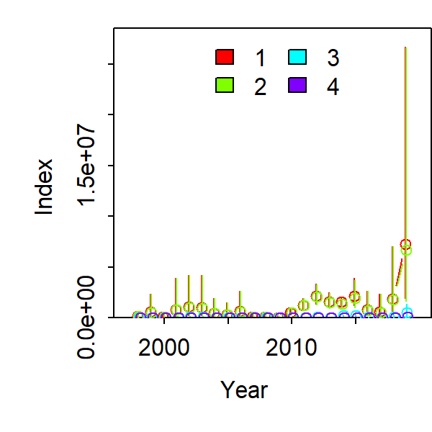

Figure . Estimated indices of abundance for the small and large squid collected during fisheries independent surveys conducted by the NWFSC and SWFSC between 1998 and 2019.

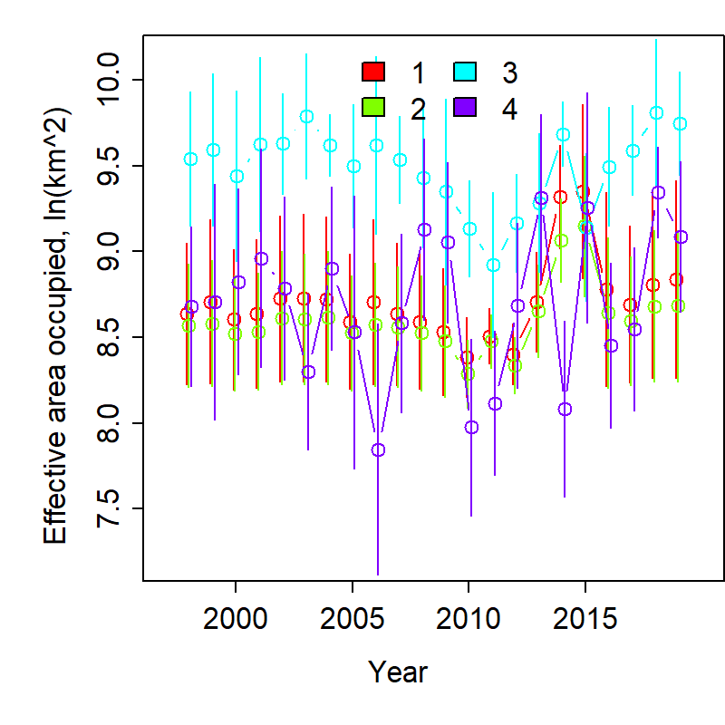

Figure . Range occupancy for small and large squid in the waters surveyed by the NWFSC and SWFSC from 1998 to 2019.